Nama : M. Mahatma Rosyid Habibillah

NIM : L200180024

Tanggal Praktikum : 20 Maret 2019

LAPORAN PRAKTIKUM SISTEM DIGITAL MODUL 4

**Percobaan 1.Substitusi Pengganti Gerbang Logika**

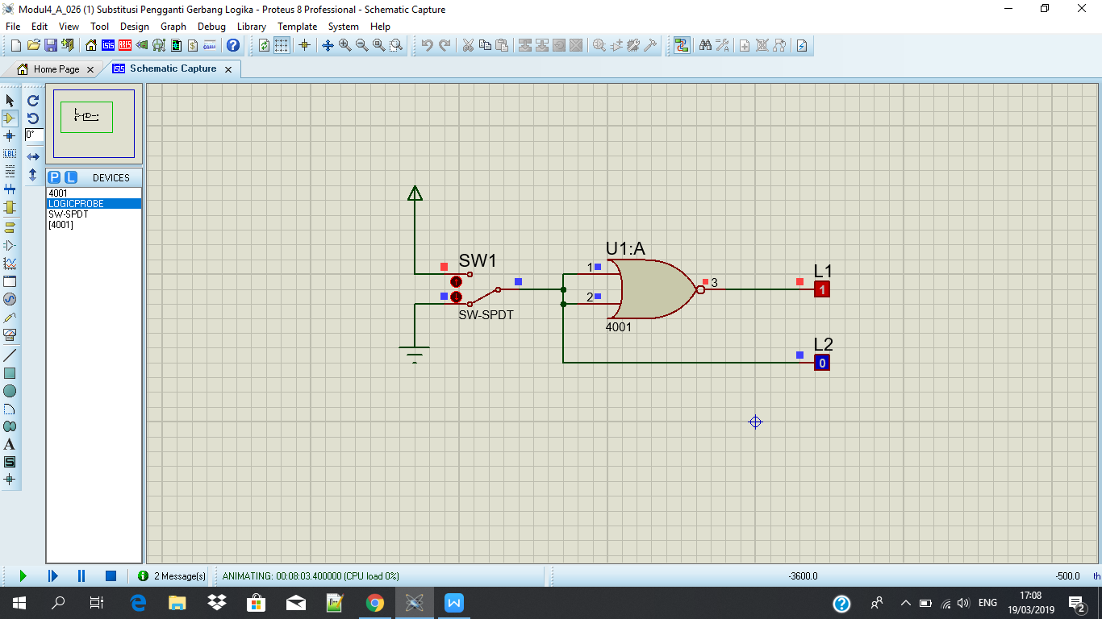

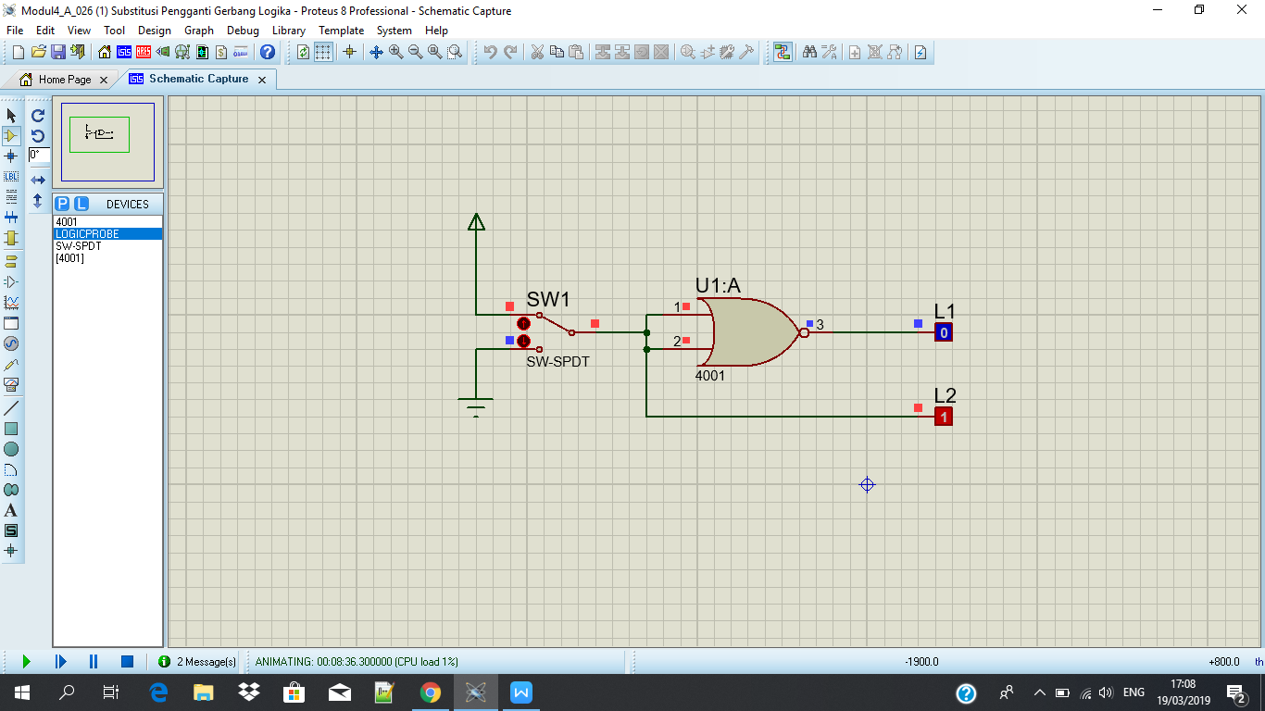

Tabel Kebenaran

|  |  |  |
| --- | --- | --- |
| SW 1 | L2 | L1 |
| 0 | 0 | 1 |
| 1 | 1 | 0 |

Diagram Waktu

|  |  |
| --- | --- |
|  | |
| 0 | 1 |
|  |

L2 :

|  |  |
| --- | --- |
| 1 |  |
|  |
| 0 |

L1 :

Fungsi Boolean :

**L1 = L2 + L2 = L2**

Kesimpulan :

Gerbang **NOR** pada gambar 4.3 membentuk gerbang logika **NOT**

**Percobaan 2. Substitusi Pengganti Gerbang Logika**

SW 1 = 0 dan SW 2 = 0

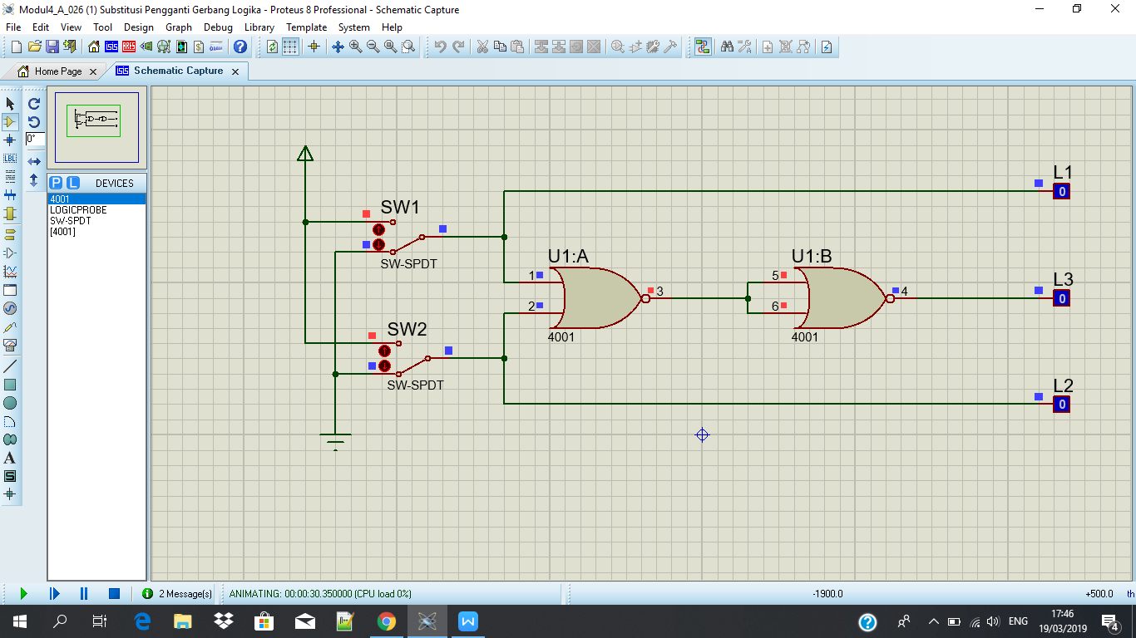

SW 1 = 1 dan SW 2 = 0

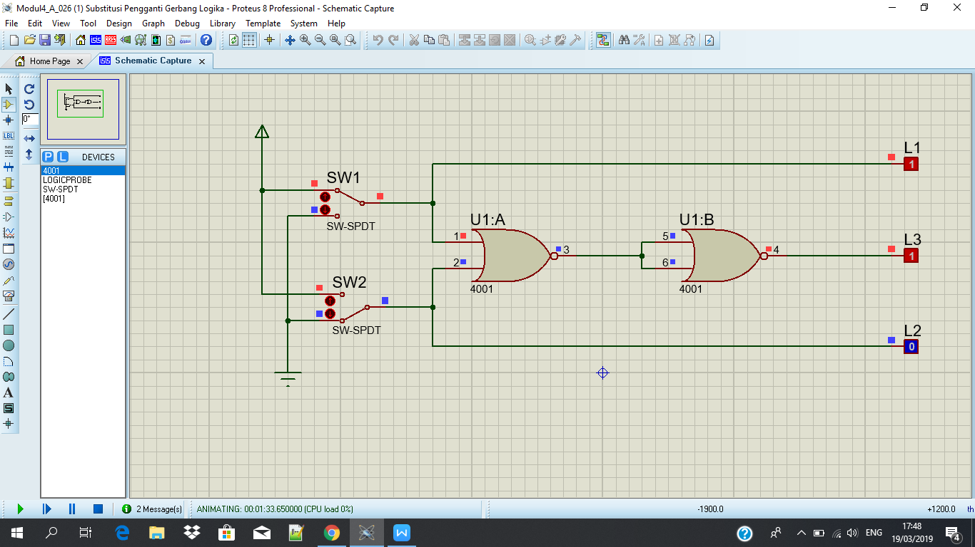

SW 1 = 0 dan SW 2 = 1

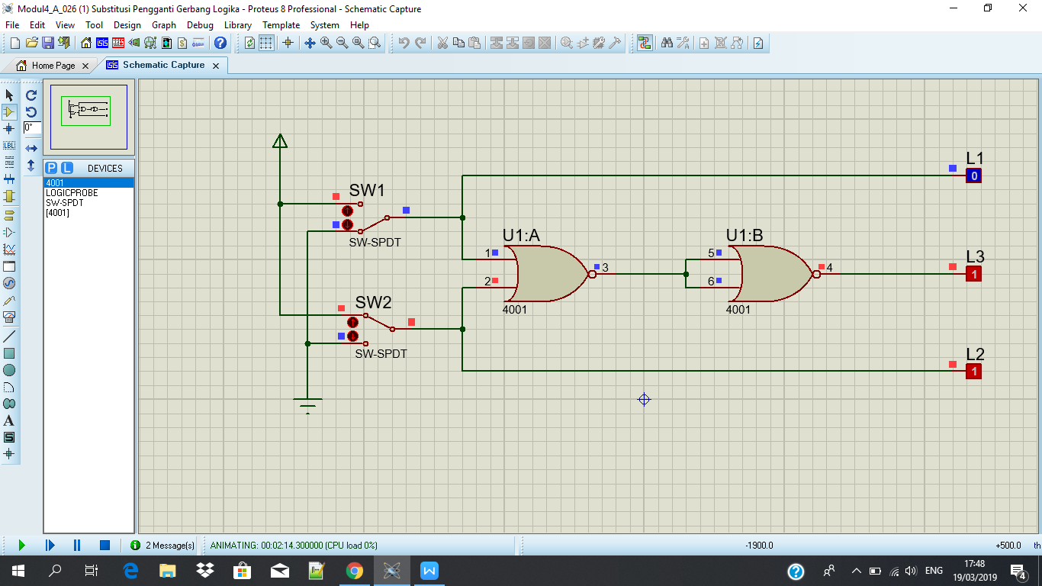

SW 1 = 1 dan SW 2 = 1

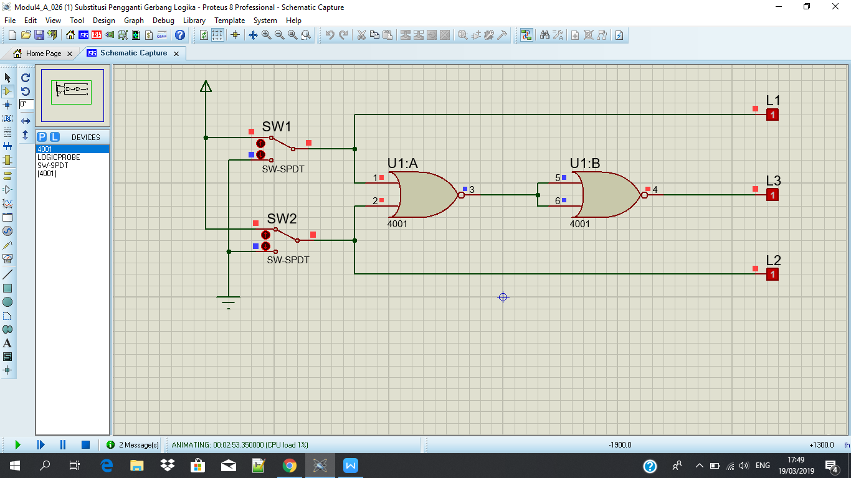

Tabel Kebenaran

|  |  |  |  |  |
| --- | --- | --- | --- | --- |
| SW 1 | SW 2 | L1 | L2 | L3 |
| 0 | 0 | 0 | 0 | 0 |
| 1 | 0 | 1 | 0 | 1 |
| 0 | 1 | 0 | 1 | 1 |
| 1 | 1 | 1 | 1 | 1 |

Diagram Waktu

|  |  |  |  |
| --- | --- | --- | --- |
| 0 | 1 | 0 | 1 |
|  |  |
| 1 | |
| 0 | | | |
|  | | | |
|  | 1 | | |
| 0 | | | |
|  | | | |

L1 :

L2 :

L3 :

Fungsi Boolean :

**L3 = L1 + L2 = L1 + L2**

Kesimpulan :

Gerbang **NOR** pada gambar 4.4 membentuk logika dari gerbang **OR**

**Percobaan 3. Substitusi Pengganti Gerbang Logika**

SW 1 = 0 dan SW 2 = 0

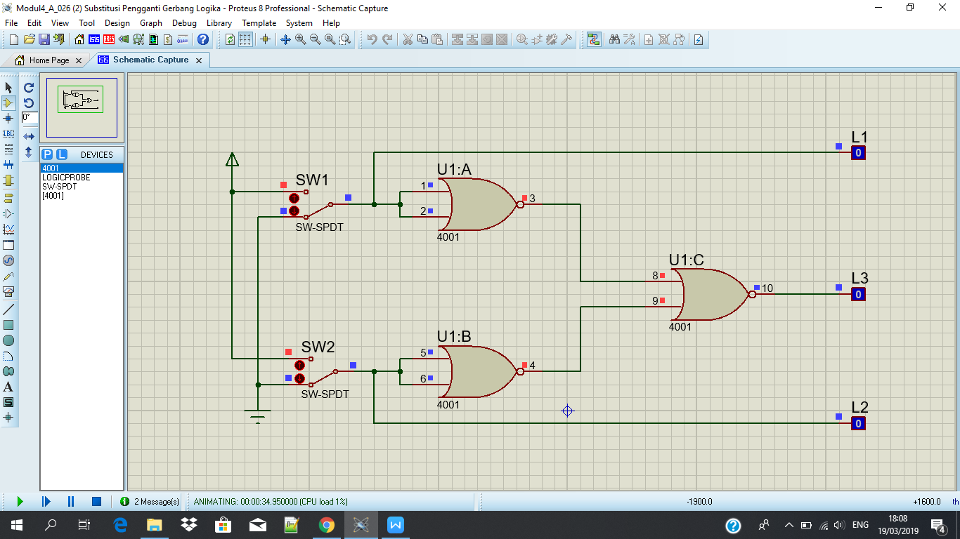

SW 1 = 1 dan SW 2 = 0

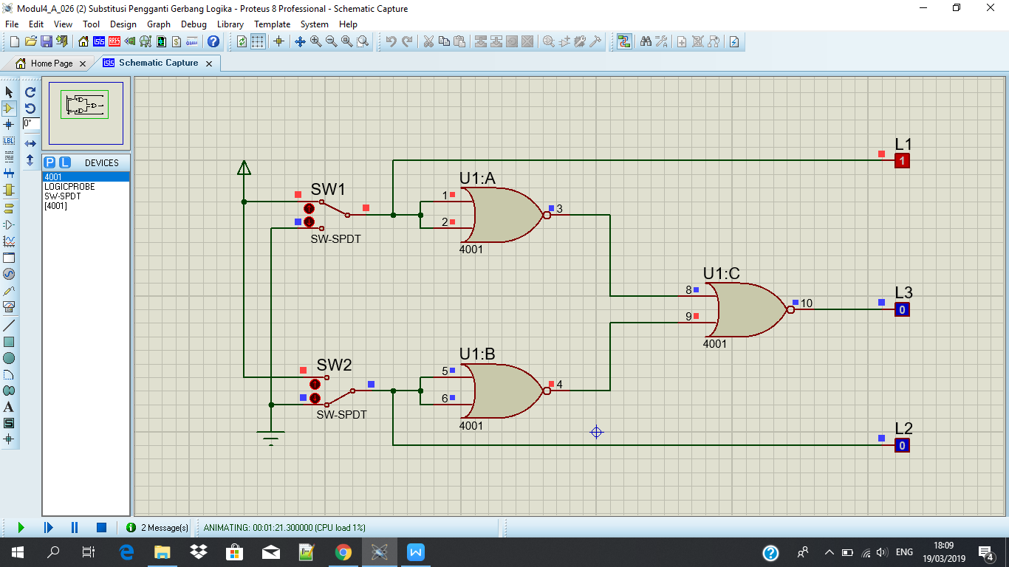

SW 1 = 0 dan SW 2 = 1

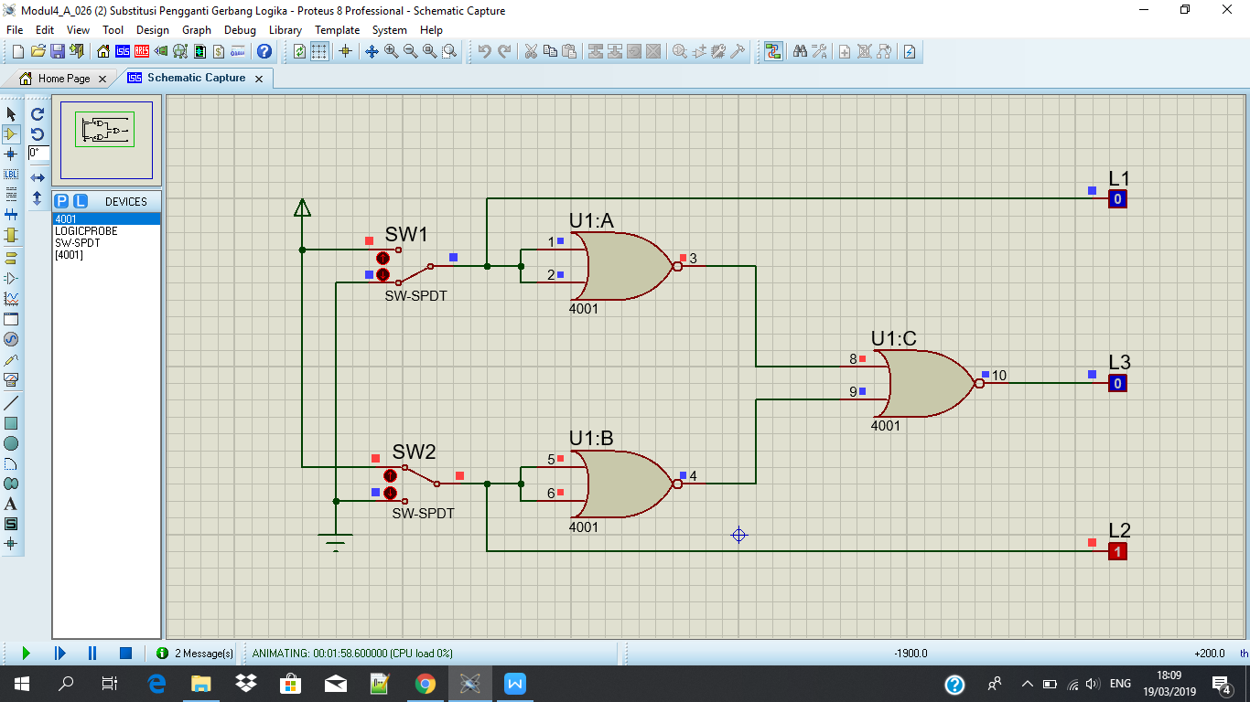

SW 1 = 1 dan SW 2 = 1

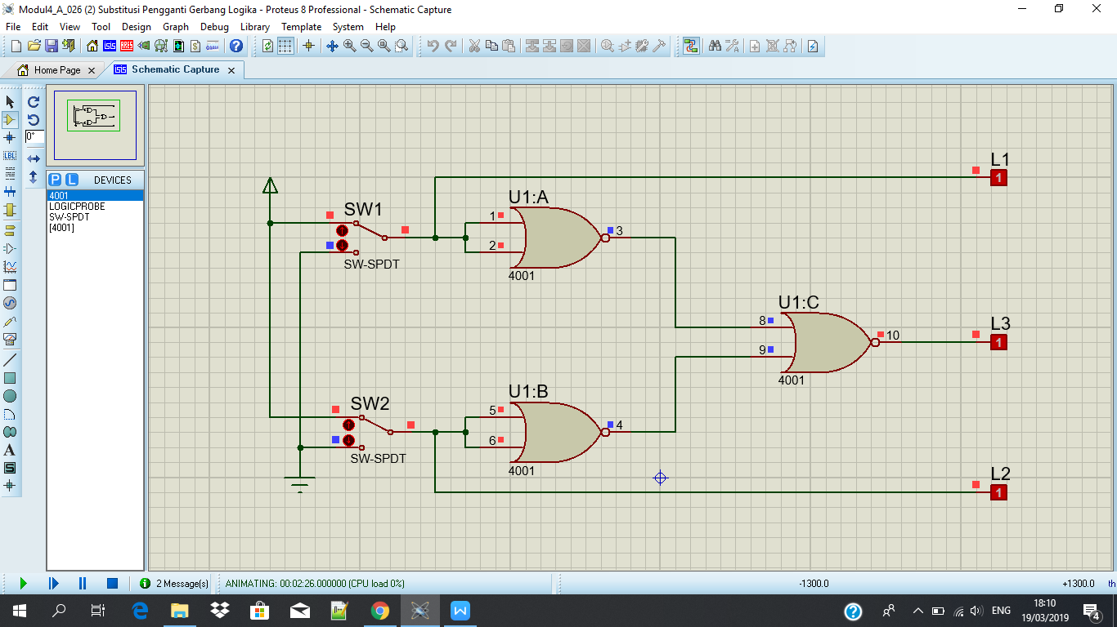

Tabel Kebenaran

|  |  |  |  |  |
| --- | --- | --- | --- | --- |
| SW 1 | SW 2 | L1 | L2 | L3 |
| 0 | 0 | 0 | 0 | 0 |
| 1 | 0 | 1 | 0 | 0 |
| 0 | 1 | 0 | 1 | 0 |
| 1 | 1 | 1 | 1 | 1 |

Diagram Waktu

|  |  |  |  |
| --- | --- | --- | --- |
| 0 | 1 | 0 | 1 |
|  |  |
| 1 | |
| 0 | | | |
|  | | | |
|  | | | 1 |
| 0 | | |
|  | | |

L1 :

L2 :

L3 :

Fungsi Boolean :

**L3 = L1 + L2 = L1.L2**

Kesimpulan :

Gerbang **NOR** pada gambar 4.5 membentuk logika dari gerbang **AND**

**Percobaan 4. Substitusi Pengganti Gerbang Logika**

SW 1 = 0 dan SW 2 = 0

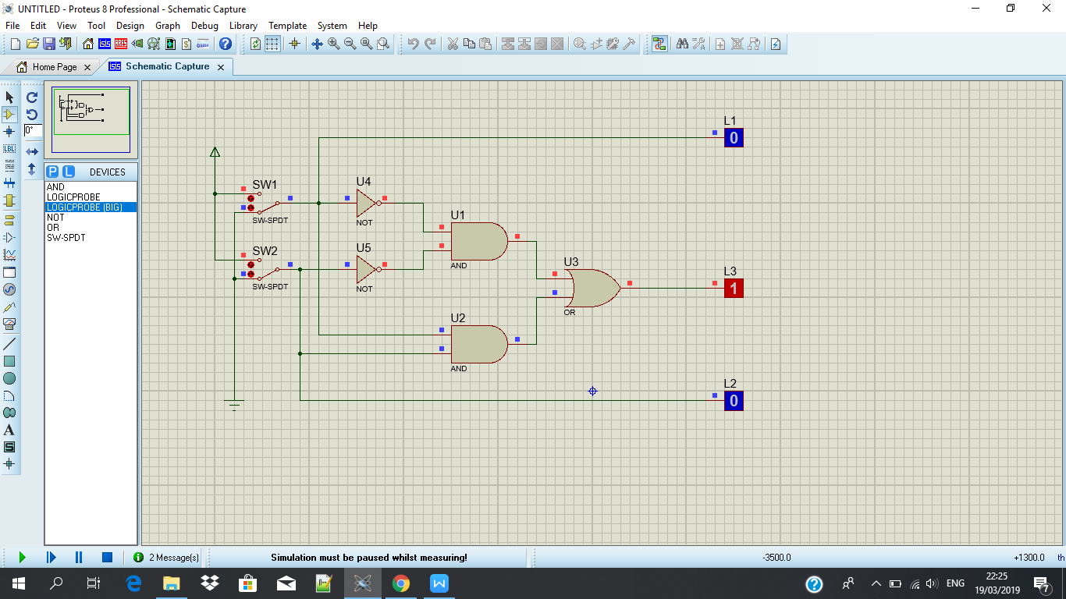

SW 1 = 1 dan SW 2 = 0

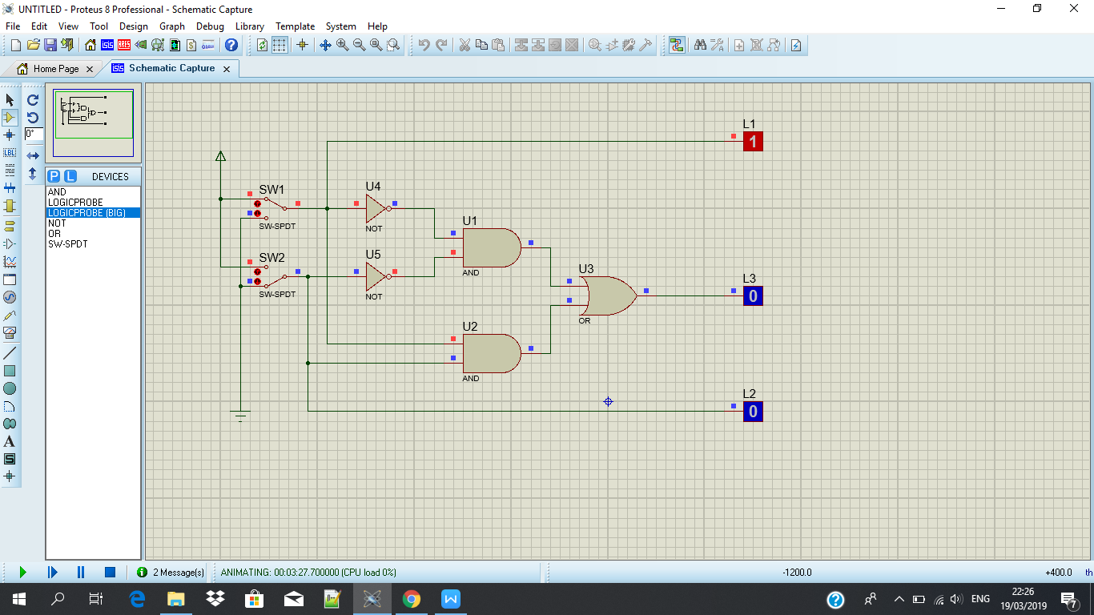

SW 1 = 0 dan SW 2 = 1

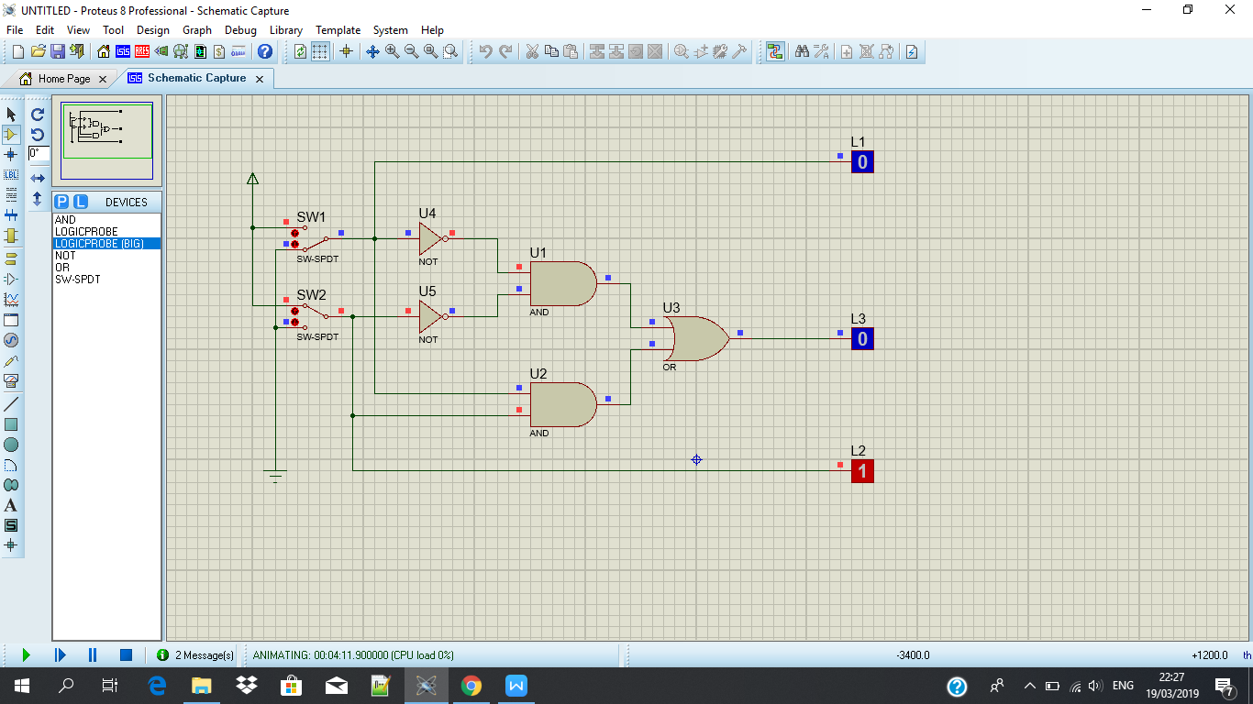

SW 1 = 1 dan SW 2 = 1

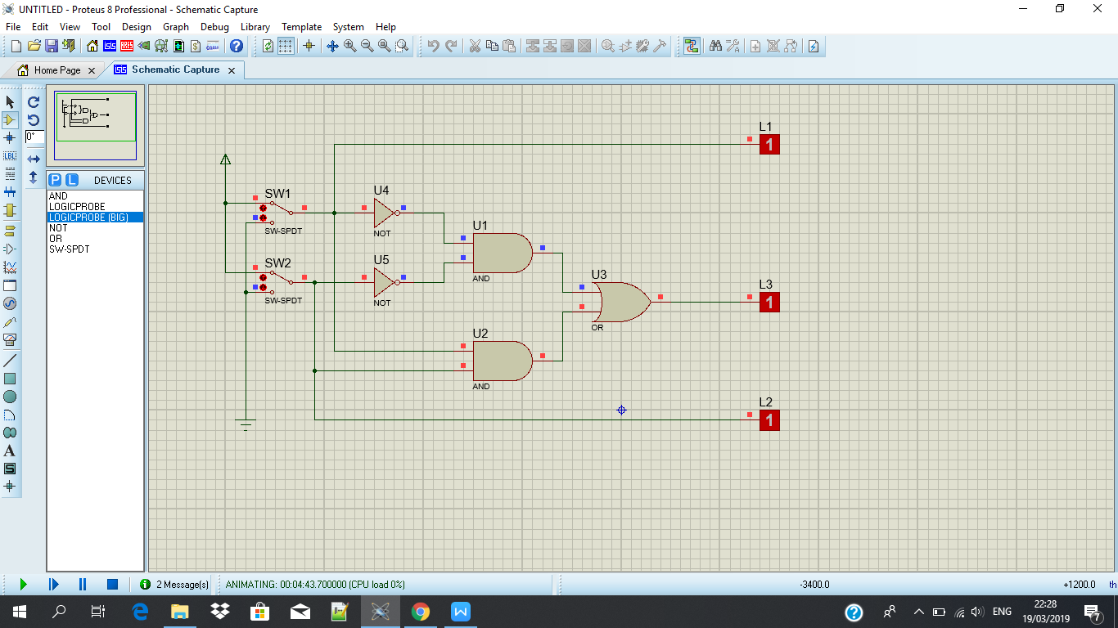

Tabel Kebenaran

|  |  |  |  |  |
| --- | --- | --- | --- | --- |
| SW 1 | SW 2 | L1 | L2 | L3 |
| 0 | 0 | 0 | 0 | 1 |
| 1 | 0 | 1 | 0 | 0 |
| 0 | 1 | 0 | 1 | 0 |
| 1 | 1 | 1 | 1 | 1 |

Diagram Kebenaran

|  |  |  |  |
| --- | --- | --- | --- |
| 0 | 1 | 0 | 1 |
|  |  |
| 1 | |
| 0 | | | |
|  | | | |
|  | | | |
| 1 |  | | 1 |
| 0 | | |

L1 :

L2 :

L3 :

Fungsi Boolean :

**L3 = L1L2 + L1L2 = L1 L2**

Kesimpulan :

Kombinasi gerbang pada gambar 4.6 membentuk gerbang logika dari gerbang **XNOR**

**Percobaan 5. Merancang fungsi Boolean ke dalam rangkaian**

Sw 1 = 0 dan SW 2 = 0

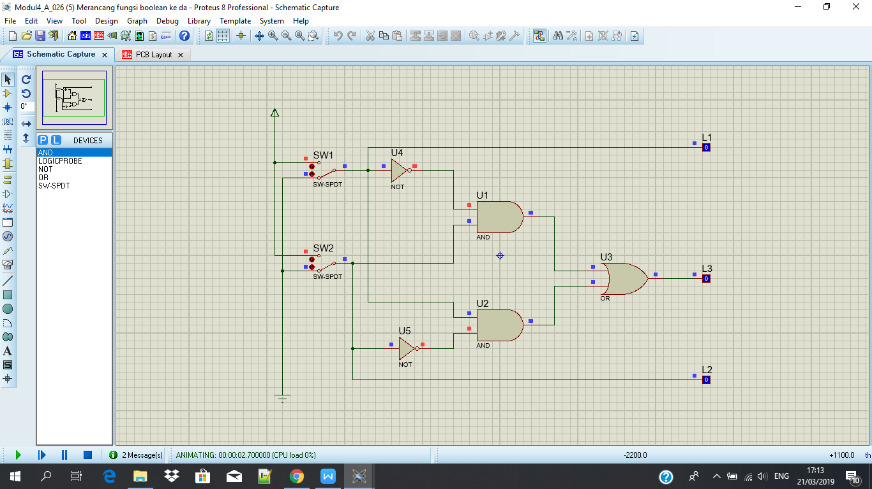

SW 1 = 1 dan SW 2 = 0

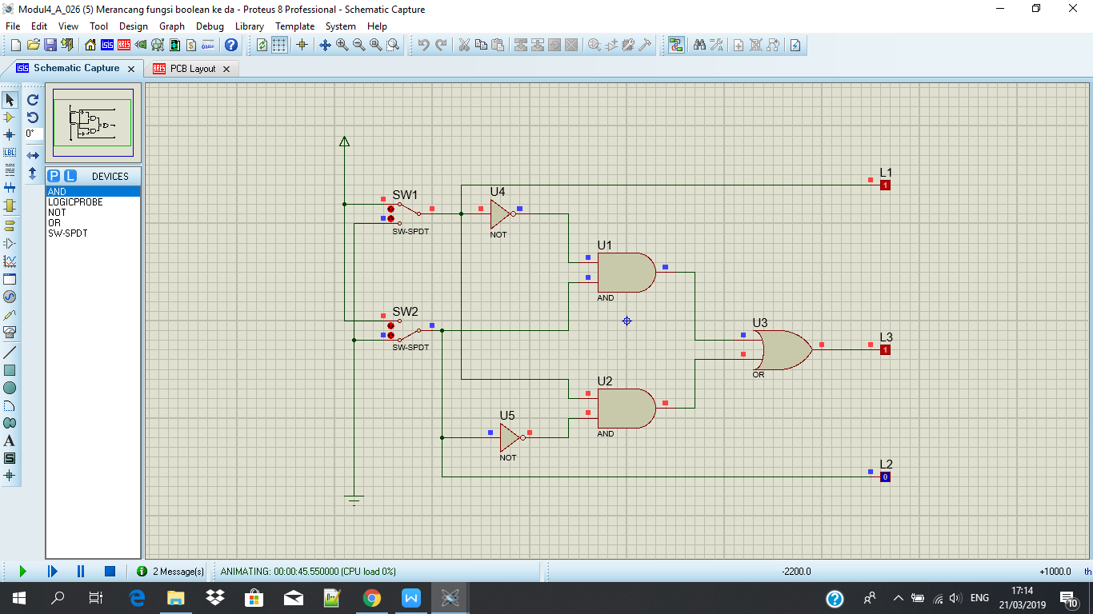

SW 1 = 0 dan SW 2 = 1

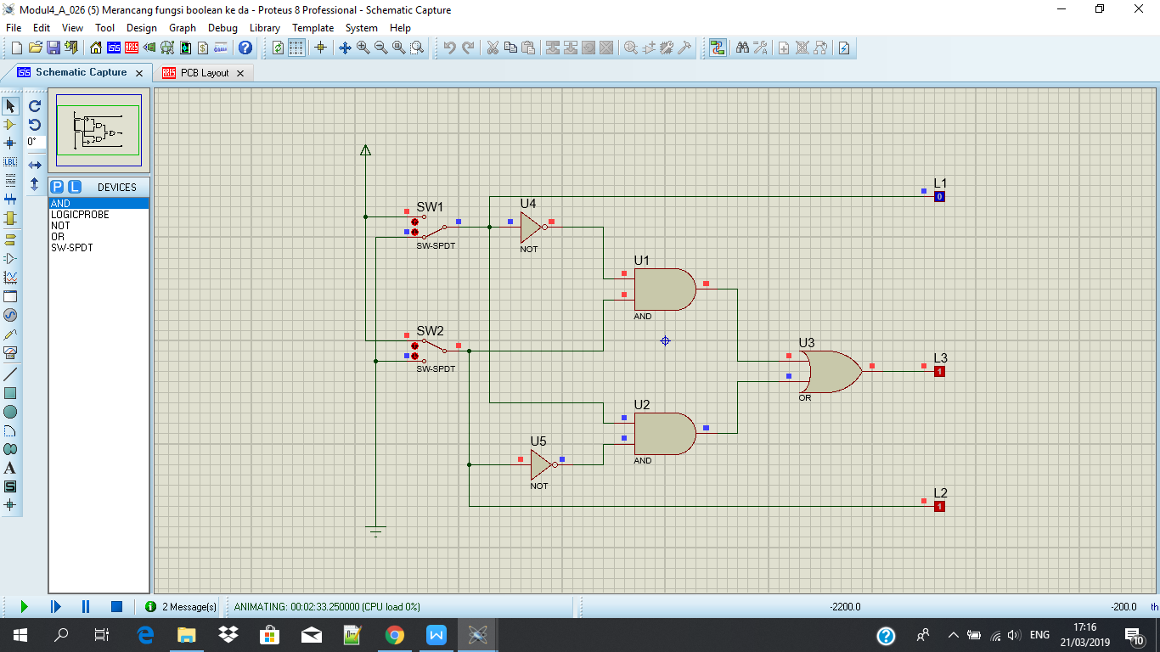

SW 1 = 1 dan SW 2 = 1

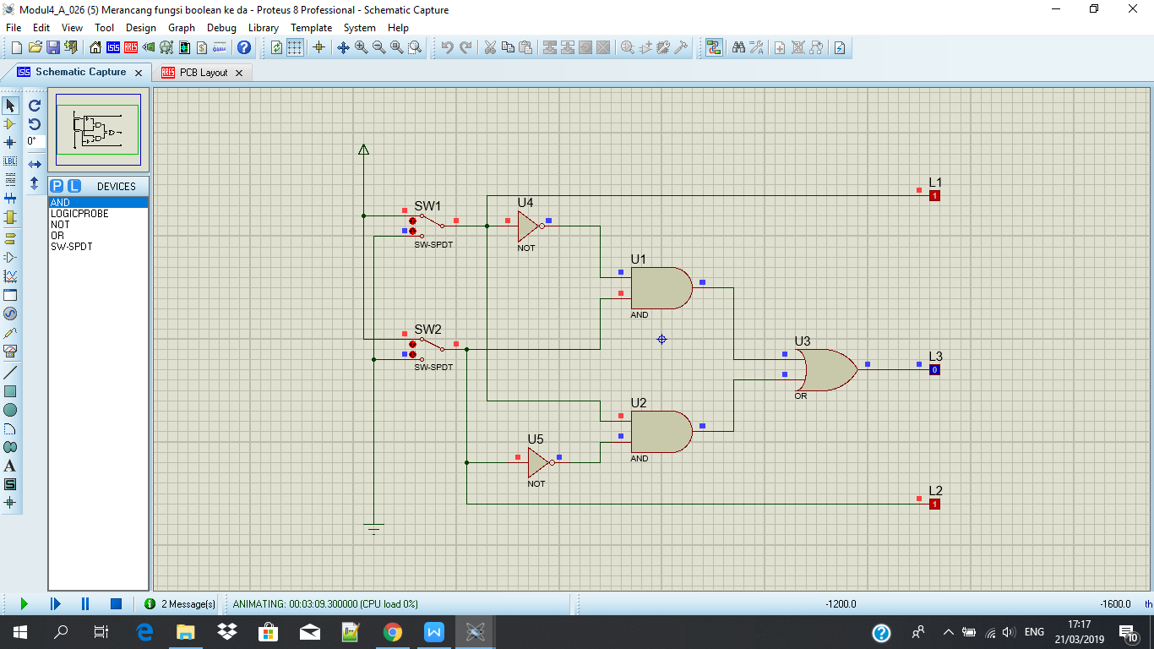

Tabel Kebenaran

|  |  |  |  |  |
| --- | --- | --- | --- | --- |
| SW 1 | SW 2 | L1 | L2 | L3 |
| 0 | 0 | 0 | 0 | 0 |
| 1 | 0 | 1 | 0 | 1 |
| 0 | 1 | 0 | 1 | 1 |
| 1 | 1 | 1 | 1 | 0 |

Diagram Waktu

|  |  |  |  |
| --- | --- | --- | --- |
| 0 | 1 | 0 | 1 |
|  |  |
| 1 | |
| 0 |  |  | |
| 1 |  |  |
| 0 | | 0 |

L1 :

L2 :

L3 :

Kesimpulan :

Kombinasi gerbang akan membentuk logika dari gerbang **XOR**